System Architecture Report

Project Title
Real-Time Sign Language Recognition and Gesture-Based Computer Control System Using Computer Vision and Machine Learning (Sign-Pilot AI)

1. Introduction
The SignNova system is designed to recognize hand signs and gestures in real time using a webcam. The application converts sign language into text and speech while also allowing users to control computer functions through predefined hand gestures. The system aims to improve accessibility and provide a touchless interaction experience.

2. Architecture Overview
The architecture follows a modular design where each component performs a specific task. The webcam captures live video, MediaPipe detects hand landmarks, the machine learning model recognizes signs, and the application generates the appropriate output.

3. System Components

3.1 User Interface (UI)
The user interacts with the application through a graphical dashboard. The dashboard provides access to:
- Sign Language Recognition Mode
- Gesture Control Mode
- Settings and Help Section

3.2 Webcam Module
The webcam captures real-time video frames and sends them to the processing module for analysis.

3.3 Hand Detection and Tracking Module
MediaPipe is used to detect and track hand movements. The module identifies 21 hand landmarks and provides coordinate information for further processing.

3.4 Feature Extraction Module
The landmark coordinates are extracted and prepared as input features for the machine learning model.

3.5 Machine Learning Model
The trained model analyzes the extracted hand landmark data and predicts the corresponding sign language gesture.

3.6 Text-to-Speech Module
Recognized signs are converted into text and then spoken through the system speaker using a text-to-speech engine.

3.7 Gesture Control Module
Predefined gestures are mapped to computer actions such as:
- Mouse Movement
- Mouse Click
- Volume Control
- Slide Navigation

3.8 Output Module
The final prediction and system action are displayed to the user through the application interface.

4. System Workflow
- User opens the application.
- Webcam starts capturing live video.
- MediaPipe detects the hand and extracts landmarks.
- Features are processed and sent to the machine learning model.
- The model predicts the sign or gesture.
- The corresponding output is generated:
  - Sign → Text and Speech
  - Gesture → Computer Action
- Results are displayed on the dashboard.

5. Architecture Diagram (Logical Flow)

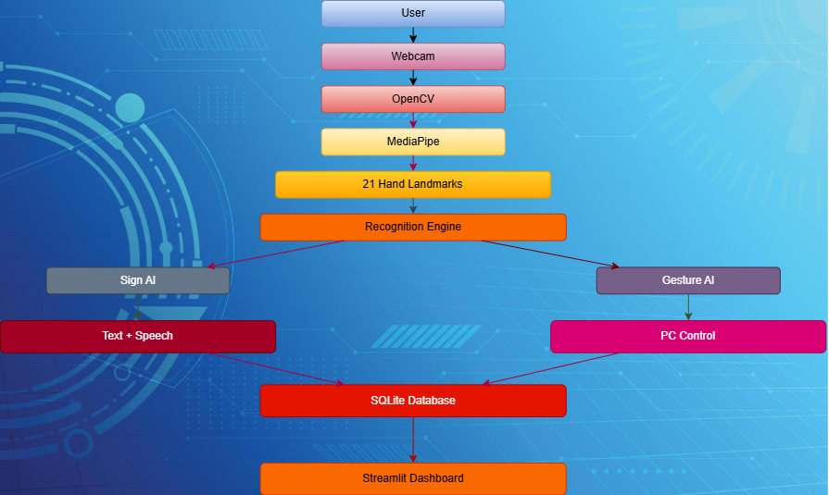

6. Benefits of the Architecture
- Modular and easy to maintain
- Real-time performance
- Works on standard laptops
- Scalable for additional signs and gestures
- Improves accessibility and human-computer interaction

7. Conclusion
The proposed architecture provides a structured framework for implementing a real-time sign language recognition and gesture-based computer control system. The modular design ensures efficient processing, easy integration of new features, and reliable system performance.

